Health Care Risk Prediction – Machine Learning Vs Neural Networks

1.Problem Understanding
Diabetes is a major public health concern worldwide, with rising prevalence linked to lifestyle factors such as obesity, sedentary behaviour, and poor diet. Early prediction of diabetes risk enables timely interventions, reducing long-term complications and healthcare costs. This project aims to build two predictive models — a traditional Logistic Regression classifier and a Neural Network — to evaluate their effectiveness in predicting diabetes risk based on patient health attributes.
2. Data Exploration Insights
The dataset includes patient demographics and lifestyle indicators: age, BMI, exercise hours per week, smoking status, and blood pressure. The target variable is diabetes status (0 = No, 1 = Yes).
Key observations from the dataset:
- Higher BMI values are strongly linked to diabetes occurrence.
- Older patients tend to have higher blood pressure.
- Smoking correlates with elevated blood pressure but not directly with diabetes.
Important features influencing prediction:
- BMI (most influential predictor).
- Age and blood pressure (secondary predictors).
- Exercise hours and smoking status show weaker influence.
Visualizations such as boxplots, histograms, and correlation heatmaps confirmed these relationships which is in Jupiter notebook. BMI ,age,blood pressure emerged as the strongest predictors.
3. Model Implementation
Machine Learning Model
- Features were scaled and split into training/testing sets.
- Logistic Regression was trained to classify diabetes.
- Achieved 90.3% accuracy but failed to predict positive diabetes cases due to class imbalance.
Feature Importance: Coefficients indicated BMI and blood pressure as the strongest positive predictors, while exercise hours had a protective effect.
Logistic regression is a supervised machine learning algorithm used mainly for classification problems where the output is categorical, such as yes/no or 0/1. It works by predicting the probability that a given input belongs to a particular class rather than giving a direct output value.
Neural Network Model
A neural network model is a type of machine learning model inspired by the human brain, designed to recognize patterns and make decisions from data. It consists of layers of interconnected nodes called neurons, including an input layer, one or more hidden layers, and an output layer. Each neuron processes input values by applying weights, adding a bias, and passing the result through an activation function to determine the output.

Architecture:
- Input layer: Accepts patient features (age, BMI, exercise hours, smoker status, blood pressure).
- Hidden layers: Dense layers with Relu activation
- Output layer
Compilation: Adam optimizer, binary cross entropy loss.
Training: 50 epochs with validation monitoring.
Visualization: Accuracy and loss curves plotted to track training progress.

4. Model Evaluation
Logistic Regression
Model Accuracy: 90.3% (but misleading).
Confusion Matrix Interpretation: Model predicts only “No Diabetes,” missing all positive cases.
Feature Importance: BMI is the most influential predictor, followed by age and blood pressure.

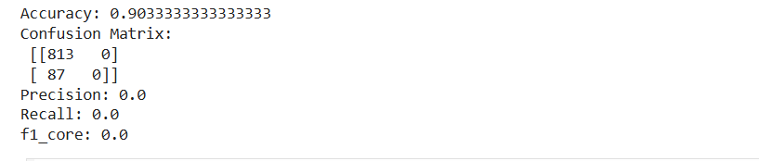
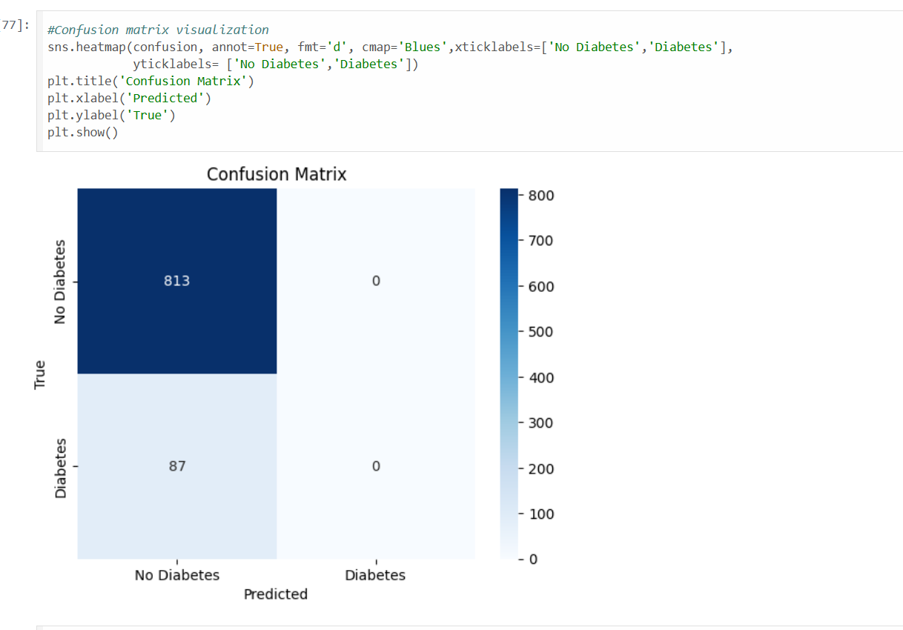

Neural Network(NN)
Model Accuracy: Training accuracy stabilized around 91%, with validation accuracy around 90%. This is comparable to logistic regression but shows the network can learn non-linear patterns.
Confusion Matrix Interpretation: The NN correctly predicts most “No Diabetes” cases, but recall for “Diabetes” cases remains low due to class imbalance. Unlike logistic regression, the NN shows slight improvement in capturing positive cases, though still limited
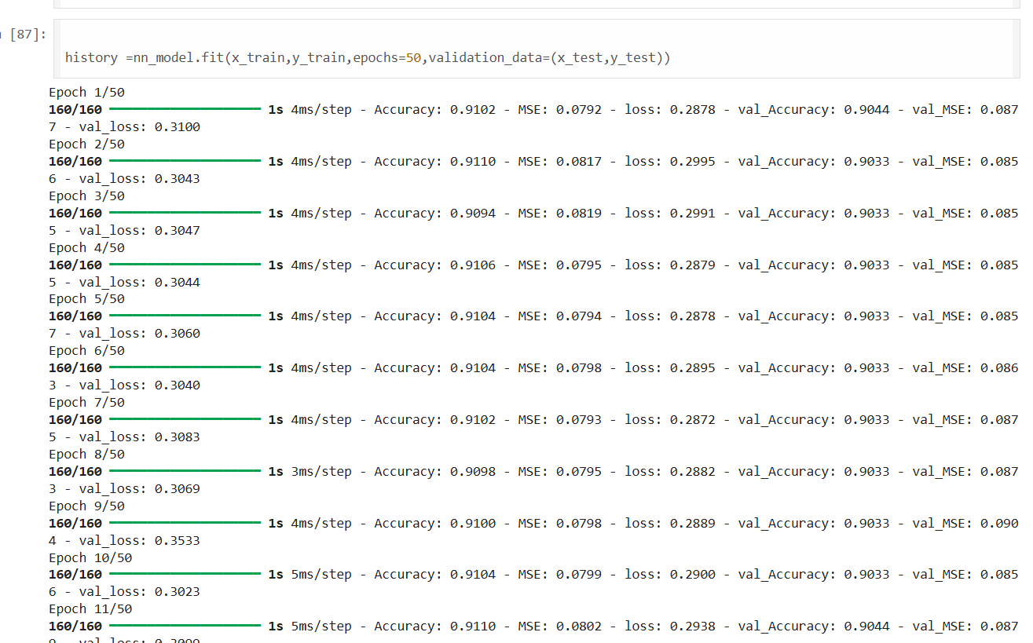
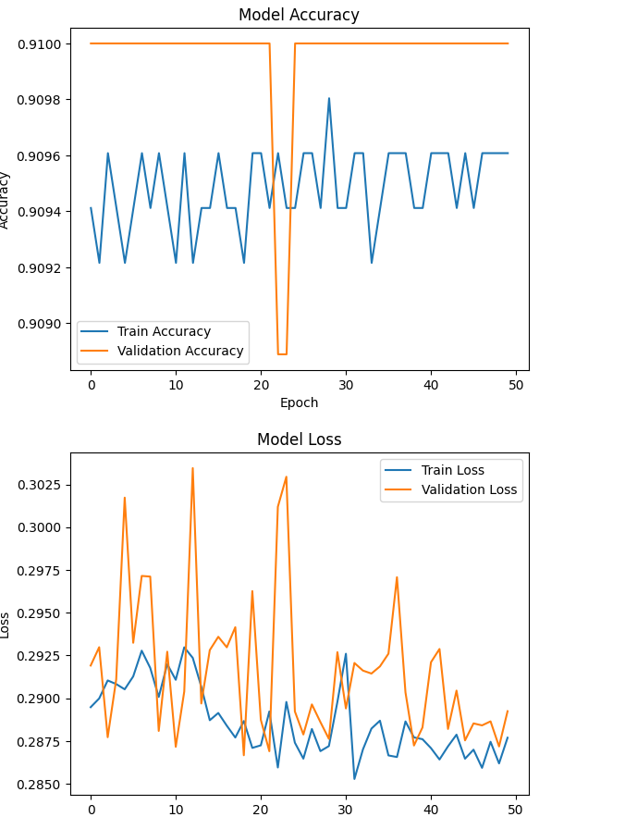
5. Comparative Analysis
Accuracy Difference
- Logistic Regression: Achieved 90.3% accuracy, but this was misleading because the model predicted only “No Diabetes” and missed all positive cases.
- Neural Network (ANN): Achieved ~91% training accuracy and ~90% validation accuracy, showing similar overall accuracy but with better generalization.
Strengths of Machine Learning Models (Logistic Regression)
- Simple, interpretable, and easy to implement.
- Provides feature importance coefficients, making it clear which variables (e.g., BMI, age, blood pressure) drive predictions.
- Works well as a baseline model for binary classification tasks
Strengths of Neural Networks
- Can capture non-linear relationships between features that logistic regression cannot.
- More flexible architecture allows learning complex patterns.
- Shows potential improvement in generalization, even with similar accuracy.
- Training visualizations (accuracy/loss plots) help monitor learning progress
Limitations of Both Approaches
- Logistic Regression:
  - Struggles with non-linear feature interactions.
  - Accuracy can be misleading in imbalanced datasets (high accuracy but poor recall).
- Neural Network:
  - Requires more computational resources and longer training time.
  - Less interpretable compared to logistic regression.
  - Still affected by class imbalance, leading to poor recall for diabetes cases.
Advantages of Neural Network
- Neural networks can model complex, non-linear relationships between health features.
- They can combine multiple weak predictors (like exercise hours and smoking status) into stronger signals.
- With proper tuning and class balancing, NNs can outperform logistic regression in detecting diabetes cases.
Situations Where Logistic Regression Might Be Preferable
- When interpretability is critical (e.g., healthcare professionals want clear reasoning behind predictions).
- When the dataset is small or balanced, logistic regression provides reliable results without overfitting.
- When computational efficiency and simplicity are priorities.
Reasons for Accuracy Differences
- Logistic Regression: Accuracy appears high because the dataset is imbalanced — most patients are “No Diabetes.” The model defaults to predicting the majority class, inflating accuracy while recall for diabetes is zero.
- Neural Network: Accuracy is slightly higher, but the NN can learn more complex feature interactions. However, without class balancing, it also struggles to correctly classify minority “Diabetes” cases, leading to low recall despite stable accuracy.

Model Choice:
- Use Logistic Regression when interpretability is essential (e.g., explaining risk factors to doctors or patients).
- Use Neural Networks when capturing complex, non-linear relationships is important, especially with larger datasets and also if sufficient resources .

